**Introduction:**

The portfolio website, titled "Ishmeet," serves as a crafted professional showcase, strategically designed to present a comprehensive display of work samples, skills, and personal branding. Its primary objective is to engage a targeted audience, including potential employers and clients, in a visually appealing and informative manner.

Through a thoughtfully curated collection of work samples, I have offered a glimpse into the creator's expertise and capabilities. Each project is presented with detailed insights, showcasing the skills and creativity applied in its execution. The website incorporates a user-friendly interface, ensuring seamless navigation for visitors seeking specific information.

The layout emphasizes clarity and accessibility, enabling users to effortlessly explore the portfolio and grasp the creator's proficiency. Strategic use of visuals, typography, and color schemes contributes to a visually engaging experience that reinforces the individual's personal brand.

Moreover, the website is optimized for the modern digital landscape, adapting seamlessly to various devices and screen sizes. This responsiveness ensures accessibility for a diverse audience and underscores the creator's commitment to staying current with technological trends.

**Site Architecture and Design Decisions**

The website adopts a simple, classic layout with a clear top menu bar for easy navigation. This traditional design prioritizes user-friendliness, providing an efficient way for visitors to explore work samples, skills, and personal branding. The deliberate choice of a familiar structure enhances the overall user experience, ensuring a straightforward and intuitive interface.

With a strategic placement, the menu bar offers quick access to key sections, maintaining a balance between practicality and aesthetic appeal. The familiarity and efficiency of this style in directing people through the website is why it was selected.

**Sitemap:**

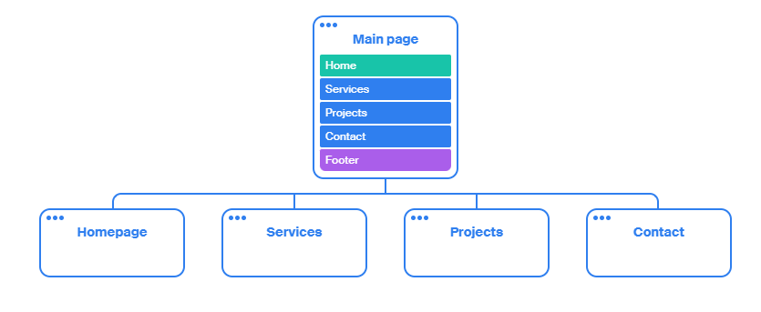

**Homepage:**

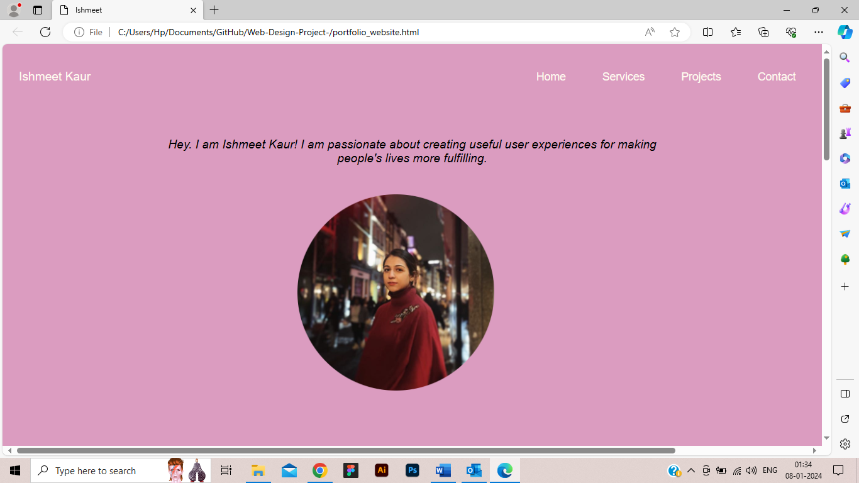

**Projects Page**:

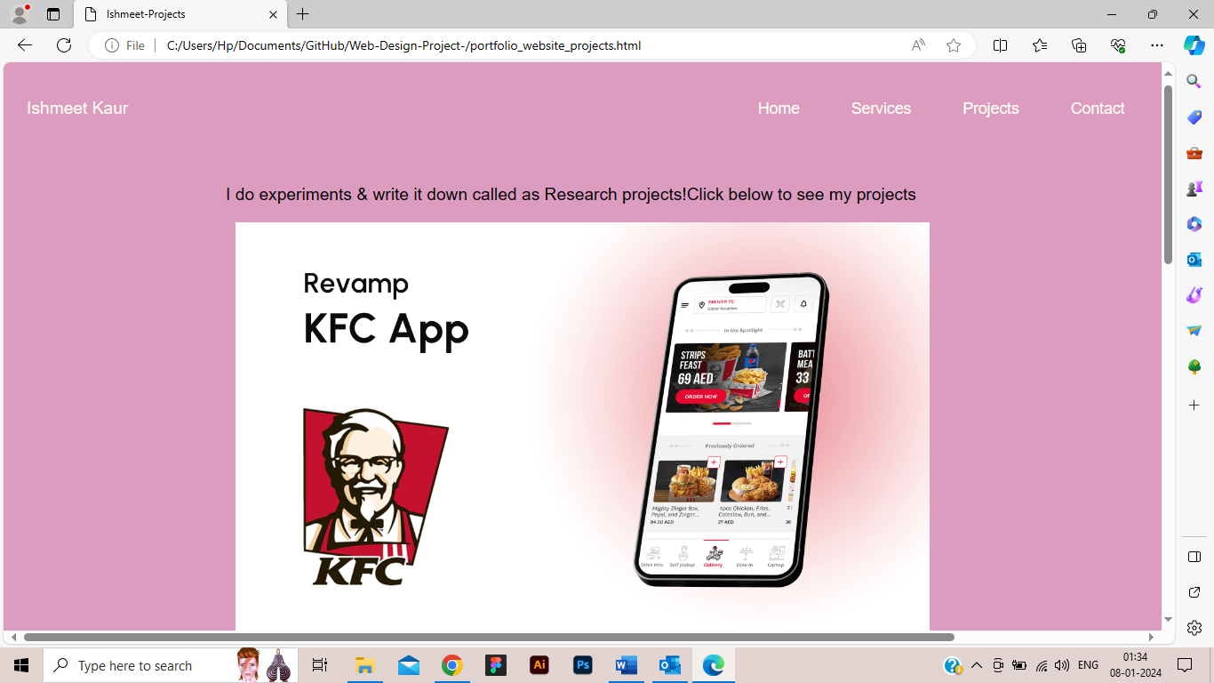

Selections for Font and Colour: Leveraging fonts with a larger size enhances readability on the website, while carefully chosen colors with strong contrasts ensure optimal visibility. These design elements contribute to a polished and inviting ambiance, aligning seamlessly with the brand. The selected Arial font, a sans-serif typeface, not only prioritizes easy readability but also maintains universality across platforms. Its widespread availability adds a practical dimension, ensuring a consistent and accessible visual experience for users. The thoughtfully curated combination of font size, color contrast, and font choice reflects a strategic approach, emphasizing both aesthetic appeal and effective communication of content on the website.

**Why good color contrast is important?**

Good color contrast is crucial in a website for several reasons. Firstly, it enhances readability by making text and content stand out clearly against the background. This is particularly important for users with visual impairments or those viewing the website in varying lighting conditions.

Secondly, effective color contrast improves user experience by providing a visually pleasing and easily navigable interface. It helps users quickly identify different elements on the page, reducing confusion and enhancing overall usability.

Moreover, proper color contrast is essential for accessibility, ensuring that the website is inclusive and can be easily accessed by individuals with color vision deficiencies. Meeting accessibility standards, such as those outlined in the Web Content Accessibility Guidelines (WCAG), is not only ethical but may also be a legal requirement in some cases.

**Web Guidelines and Usability**

Web Standards: The site adheres to HTML5 and CSS3 standards, ensuring cross-browser compatibility and future-proofing.

Accessibility: Key accessibility features include semantic HTML elements, alt attributes for images, and keyboard-friendly navigation.

The "Services" page on portfolio website effectively showcases professional offerings. It combines a clear, user-friendly design with a professional tone. The layout, color scheme, and typography choices align with the overall aesthetic of your portfolio, ensuring a cohesive user experience. Web standards and accessibility guidelines are meticulously followed, ensuring a wide reach. Challenges like cross-browser compatibility and responsive design were addressed, enhancing the page's functionality across various devices. This page is pivotal in detailing your services, playing a key role in attracting and informing potential clients or employers.

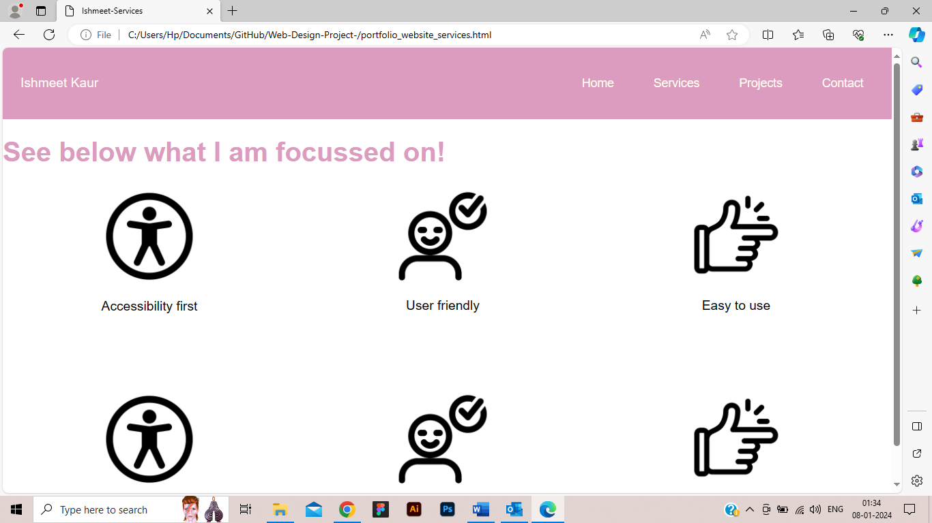

The "Contact" page of portfolio website is designed with a focus on user accessibility and professional presentation. It features a clear layout, making use of a consistent color scheme and typography aligned with the overall portfolio theme. Key elements include a user-friendly contact form, easy navigation, and responsive design for accessibility across various devices. The page adheres to web standards, ensuring cross-browser compatibility and incorporates accessibility features like image alt tags and keyboard navigation. Challenges addressed during development include optimizing for mobile responsiveness and ensuring a seamless user experience. This page effectively serves as a direct communication link within the portfolio, enhancing user engagement and professional reach.

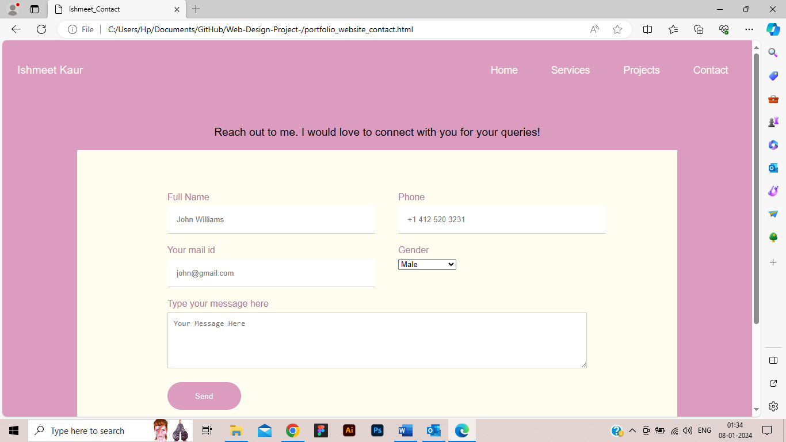

**Technical Implementation**

HTML Structure: Semantic tags like <nav>, <article>, and <div> are used for clarity and accessibility.

CSS Styling: External stylesheet (style_homepage.css) is employed for a clean separation of content and presentation.

Resources: Utilized W3CSchools, MDN Web Docs, and Stack Overflow for best practices and troubleshooting.

**Design Approach and User Experience**

User-Centric Design: Focusing on user experience, the design of this portfolio is customized for a smooth and captivating interaction. The layout and content are carefully crafted to emphasize the presentation of portfolio pieces. The user-centric approach ensures that visitors encounter a seamless and engaging journey through the website, prioritizing the effective display of showcased work.

Understanding User Needs: Catering to user needs, the design is crafted with a thoughtful consideration of the user's entire journey, starting from the initial impression and extending to in-depth exploration of the portfolio.

**Limitations and Challenges**

Dynamic Content: The current version lacks interactive elements like JavaScript-based animations, which could enhance user engagement.

Browser Compatibility: Addressed challenges in ensuring design consistency across various browsers through testing and CSS normalization.

Screenshots and Validation

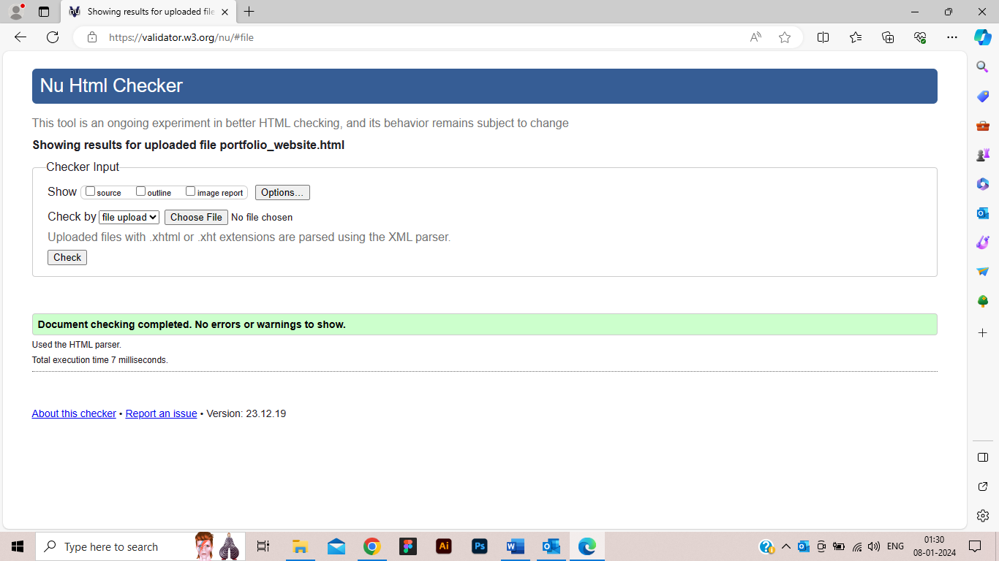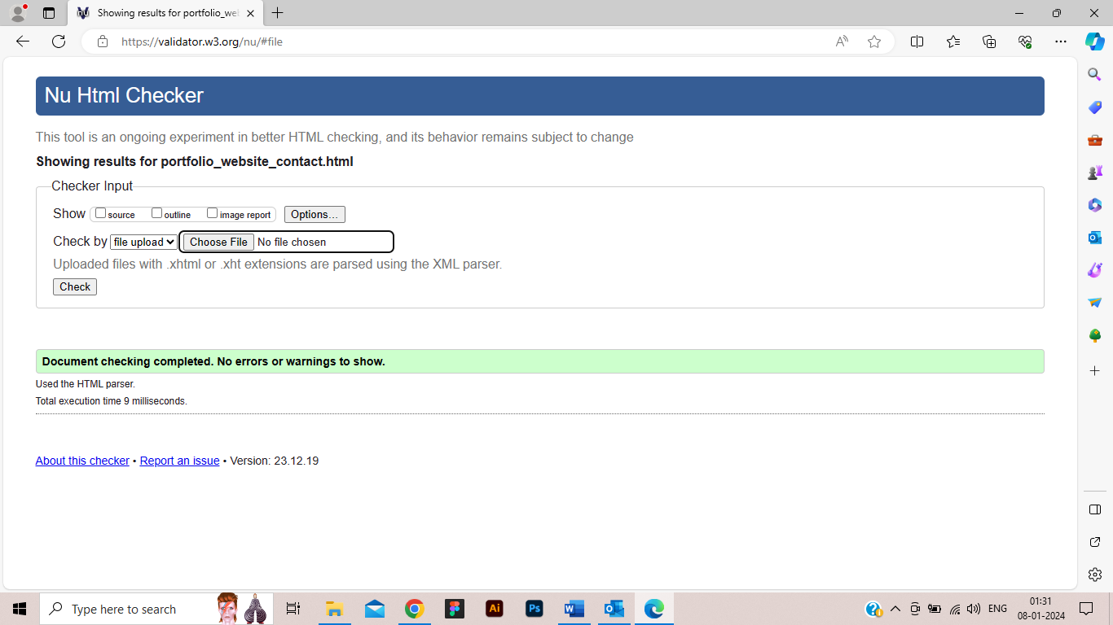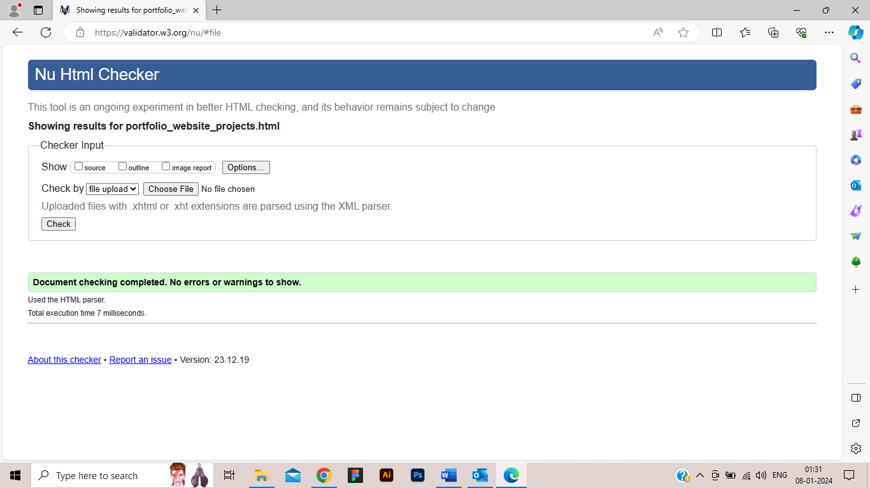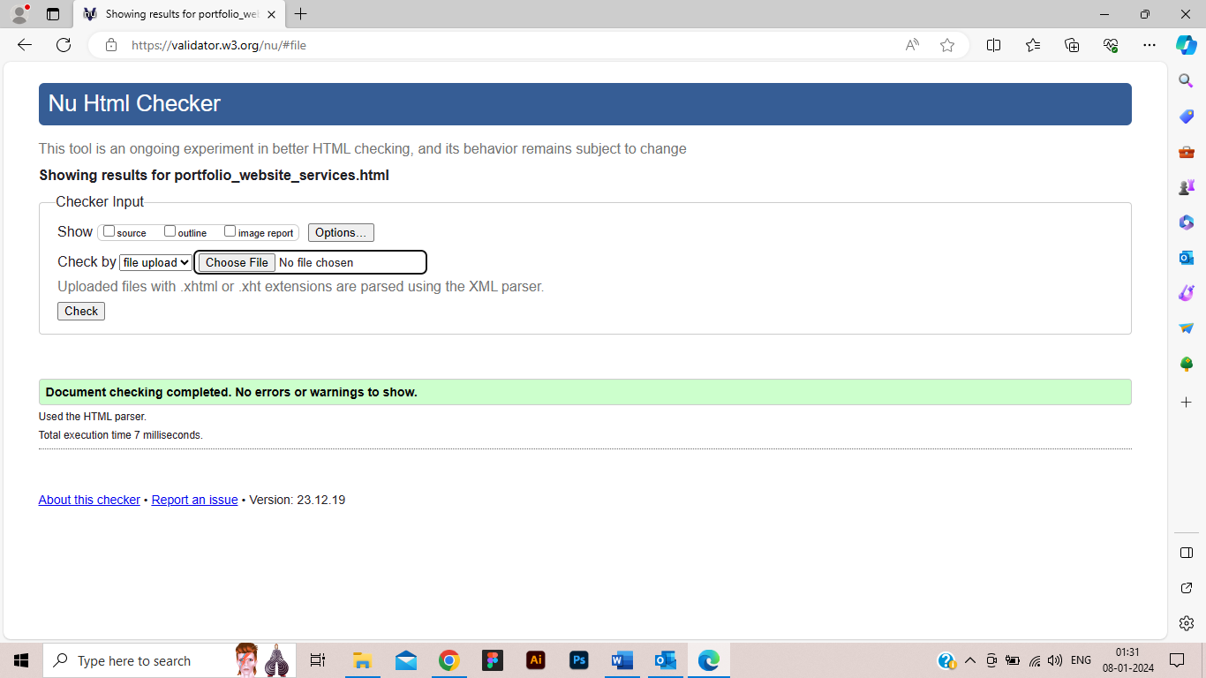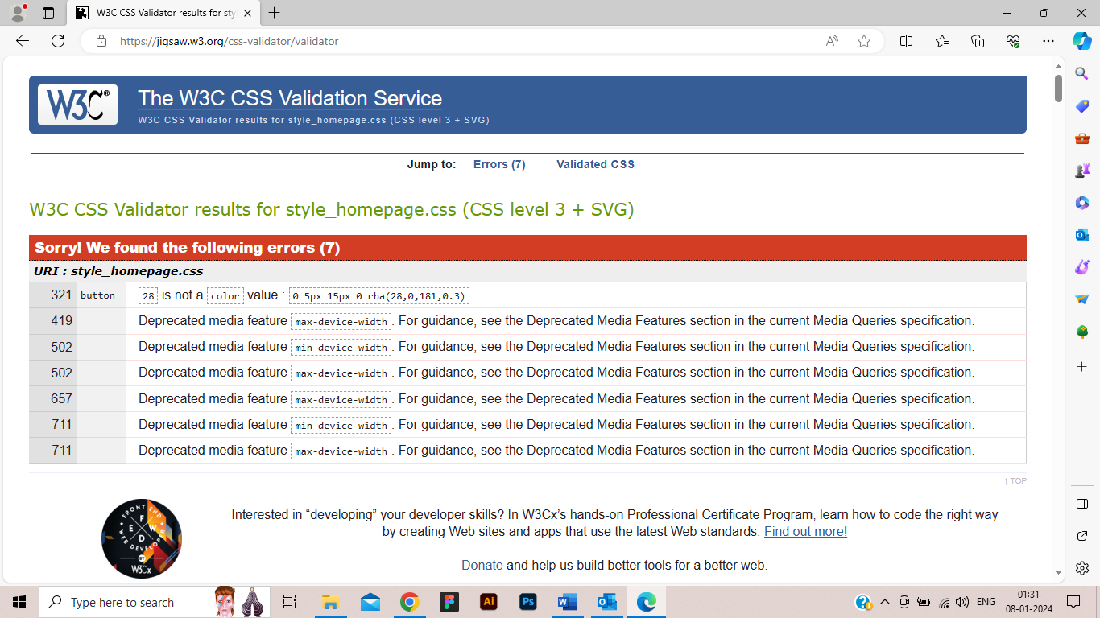

Conclusion

The portfolio website represents a thoughtful balance of professional showcasing and user-centric design. While there is room for enhancement in interactivity and dynamic content, it stands as an effective platform for professional representation.